**Team Mission:** .

Our mission is to create a community of student and adult leaders passionate about science, technology and engineering. We aim to provide an environment centered around fostering intellectual creativity, cooperation, and competition, as we all work together to develop critical thinking, problem solving, and team building skills. In addition, our goal is to make a positive impact in our school and general communities, while promoting the ideals of FIRST.

**Team Origin:**

Our team was founded in September of 2010 at Canyon Crest Academy in San Diego, California as part of the CCA Robotics Program and meets afterschool in a team member’s garage. De.Evolution Team 4278 has maintained between 7-10 members over the last four years but actually functions as part of a greater business model including three FTC teams and One FRC team. Thanks to combined resources and team coordination our influence in the community has skyrocketed, allowing us to acquire more resources, better workspaces for our class and FRC teams as well as awesome mentors. In addition, alumni team members have come back to share their knowledge and experience with both FRC and FTC teams. One of the challenges our program has had to overcome over the years is a lack of facilities and resources. Throughout the lifetime of our team, we’ve had to make do with small spaces and a lack of access to more advanced tools. Thanks to a robust model for sponsorship and fundraising we have seen significant growth in our design process this year, in which the vision for our robot was completed quickly and efficiently using 3D modeling/design and advanced materials. While we began with a limited set of skills and experiences, through our failures we have been able to come up with better designs in a much shorter amount of time. We’ve successfully developed a program that promotes the values of FIRST to students and our community, and will continue to for years to come.

**Organizational Structure:**

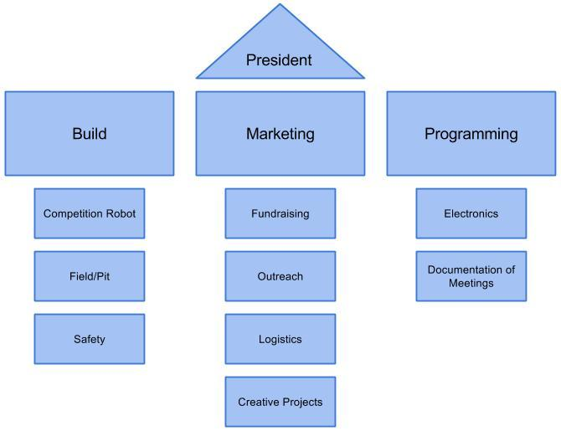

**Relationships:**

As part of the Canyon Crest Academy Robotics Program our team takes the relationships between our students, mentors, and community very seriously, and we aim to be continuously improving our connections with them. Team 4278 leaders work within the organizational structure above to expand access to STEM within our entire school and the community. As part of this business model we plan to offer nights during the year in conjunction with our other teams where students and parents can come on campus to our student-run cafe to enjoy food and beverages while seeing demonstrations of robots and learning more about the different robotics programs at our school. Furthermore, we plan to sell special fan shirts to enable fellow students and teachers to show their support for the teams, serving the teams financially as well as fostering school spirit. We often partner with the Humanities Conservatory at our school for assistance with writing grants and seeking out sponsors. Corporate support is allocated to each of the four teams within the program. We are grateful for the continued support of our veteran sponsors, and are actively looking for new contacts through our local community. This year, we’ve reached out to four additional companies and are continually seeking more in pursuit of this goal. We also join with other facets of our school during the annual pep rally and Quest/STEM Nights to get people excited about STEM. In the spirit of Coopertition, we often partner with various FTC and FRC teams in our area; as we exchange knowledge, resources and experiences, we gain valuable input and perspectives that benefit everyone. Internally, we are constantly on the lookout to plan awesome team building events and trips that give us the chance to grow closer as a group. Overall, we really value the relationships within our team and in our community, and we hope to strengthen these over time.

**Deployment of Resources:**

Our team greatly values our community and aims to engage it in activities that further the appreciation of science, technology, engineering, and mathematics. Because of this, we have specifically organized our resources to maximize our ability to both inform and involve our community in STEM subjects. We regularly excite members in our school through events like Club Day, Quest Night and Parent Night, where we show our robot to a large amount of people and get them interested in robotics. Furthermore, we plan and participate in school-wide events like our school’s biannual pep rally to stimulate fascination amongst the student body. We also aim to spread the word of FIRST to middle and elementary schools with a goal of exposing students to STEM. Our objective in demonstrating at schools is to both start new FLL and FTC teams and get kids interested in robotics, as well as partner with already existing FTC and FLL teams as mentors. By mentoring others, we challenge team members to expand their skillsets and solidify the knowledge they’ve already acquired. As a team, our goal is to spread the message of FIRST everywhere we can and to create communities for students, parents, and teachers aiming to improve their critical thinking, team building, and problem solving skills, and support science, technology, engineering and mathematics.

**Future Plans:**

While planning our next three years, our team’s main goals are to promote the core values of FIRST, to encourage the growth of a supporting and excited community, and to make an impact outside of robotics and engineering related areas. For instance, in order to establish connections between people through robotics, we plan to host fundraisers at various restaurants on the first Tuesday of every month. By doing this, we aim to not only raise funds to continue the impact of our team, but also bring together a community focused on STEM by being a reliable location for friends and family to meet each other while actively supporting the team. We also plan to continue to grow our relationship with the art programs at our school, to involve them in actively supporting our team and FIRST. We plan to partner with our cinema and art conservatories to help our marketing team expand its capabilities in the realms of graphics and videography. Outside of competition and robotics, our team values making an impact within the community. We plan to partner with other teams in our area to organize regular beach cleanups along the coast in order to help the environment. Furthermore, we plan to continue to reach out to companies for grants to allow us to grow our team and reach even more students in more diverse ways. Our team is focused on engaging our community both inside and outside of school, all in the name of STEM, and over the next three years we believe we can build relationships more effectively with the people around us.

**Financial Statement:**

Team 4278 Income

Starting Balance: $3,795.78

Sponsorships: $4,500.00

(SAIC/Leidos, Nordson Asymtek, Canyon Crest Academy Foundation)

Member Donations: $100

Fundraising*: $300

**Total: $8,695.78**

Team 4278 Expenses

San Diego and Los Angeles Qualifiers: $325.00

San Diego Regional: $125.00

Los Angeles Regional: $150.00

Super Regional: $500.00

World Championship: $1,000.00

Build Season Supplies (Materials, Parts, Services, Field, etc.): $3,629.82

Marketing Supplies (Shirts, Wristbands, Flyers, Events, etc): $650.00

Teacher Travel Expenses: $1,000.00

**Total: $7,379.82**

End Balance: **$1,315.96**

*Figures reflect projected values at the end of the fiscal year

Total Sponsorship income for all four CCA Robotics teams: **$27,800.00**

**Risk Analysis:**

In our quest for improvement, we aim to assess our strengths, weaknesses, opportunities and threats to make sure we can make decisions effectively. Our main strengths center around the plethora of dedicated people on our team willing to put their full passion towards furthering the goals of the team, and constant support from companies and generous parents in our community. And while our team has a good foundation, we also have an enormous number of opportunities to further spread the FIRST message to the abundance of middle and elementary schools in our area. However, to best utilize our strengths, we must also be aware of our weaknesses. Our team tends to rely heavily on our experienced members, meaning that newer members aren’t learning as much as they could be. We intend to mitigate this by establishing smaller working groups and individualized projects to give newer students the chance to grow. Also, while building our team we have drawn back from establishing ourselves within the school and working in our community, and plan to confront this problem head-on by making outreach events a staple in our team. We also suffer from the constant coming and going of talented team members. Our team aims to soften this impact by emphasizing a strong student mentoring program to ensure that knowledge and skills are passed down. We are always looking for new ways to attract members and continue the impact of our team, and we believe that with the resources and students we have available, plus sound planning, we can strengthen our weaknesses and build a better team, community, and world.